Assignment 8(DBMS)

1.Create Database PCCOE

use PCCOE_289

2. Create following Collections
Teachers(Tname,dno,dname,experience,salary,date_of_joining )
Students(Sname,roll_no,class)

use PCCOE_289

db.createCollection("Teachers_289")
db.createCollection("Students_289")

db.Teachers_289.insertMany([
{
Tname: "Amit",
dno: 1,
dname: "Computer",
experience: 5,
salary: 12000,
date_of_joining: "2018-06-01"
},
{
Tname: "Sneha",
dno: 2,
dname: "IT",
experience: 3,
salary: 9500,
date_of_joining: "2019-07-15"
},
{
Tname: "Ravi",
dno: 3,
dname: "E&TC",
experience: 4,
salary: 10500,
date_of_joining: "2020-01-10"
}
])

db.Students_289.insertMany([
{ Sname: "John", roll_no: 1, class: "SE" },
{ Sname: "xyz", roll_no: 2, class: "TE" },
{ Sname: "Anjali", roll_no: 3, class: "BE" }
])

3. Find the information about all teachers

db.Teachers_289.find().pretty()
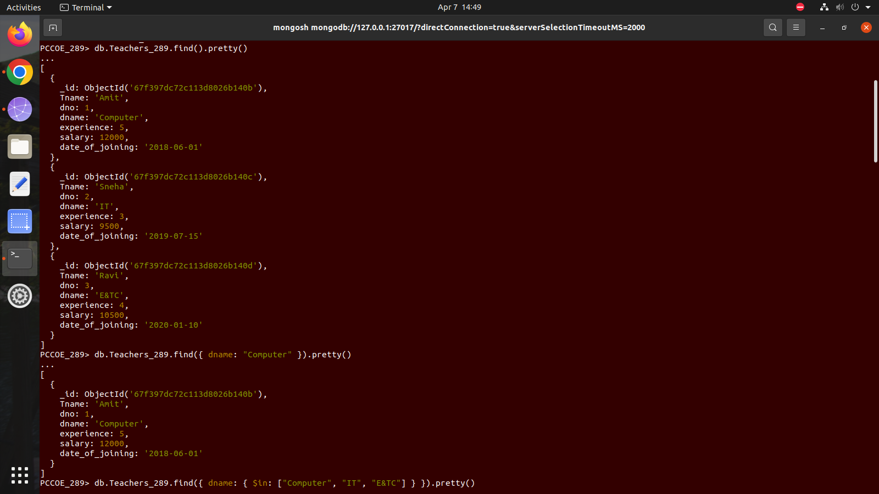
4. Find the information about all teachers of computer department
db.Teachers_289.find({ dname: "Computer" }).pretty()

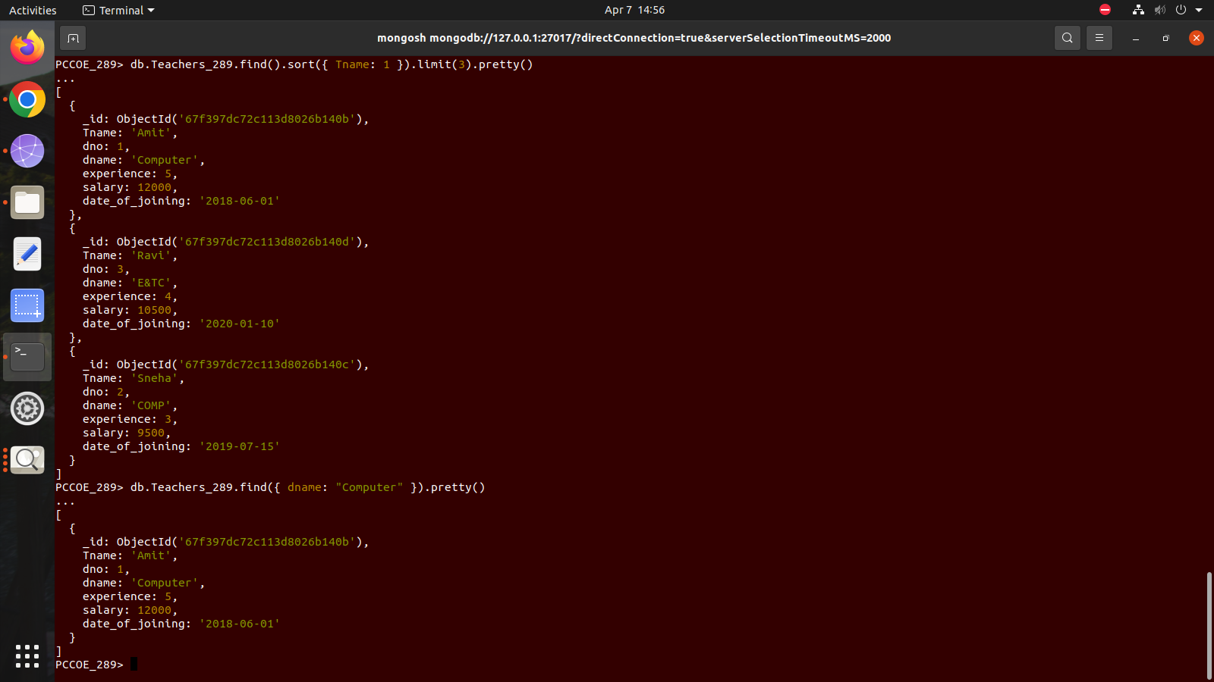

5. Find the information about all teachers of computer,IT,and e&TC department

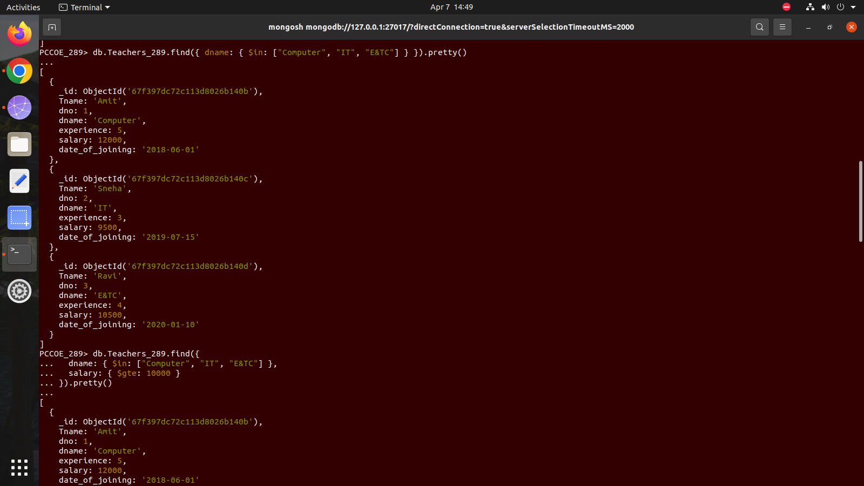
db.Teachers_289.find({ dname: { $in: ["Computer", "IT", "E&TC"] } }).pretty()

6. Find the information about all teachers of computer,IT,and E&TC department having salary greater
than or equal to 10000/-

db.Teachers_289.find({
dname: { $in: ["Computer", "IT", "E&TC"] },
salary: { $gte: 10000 }
}).pretty()
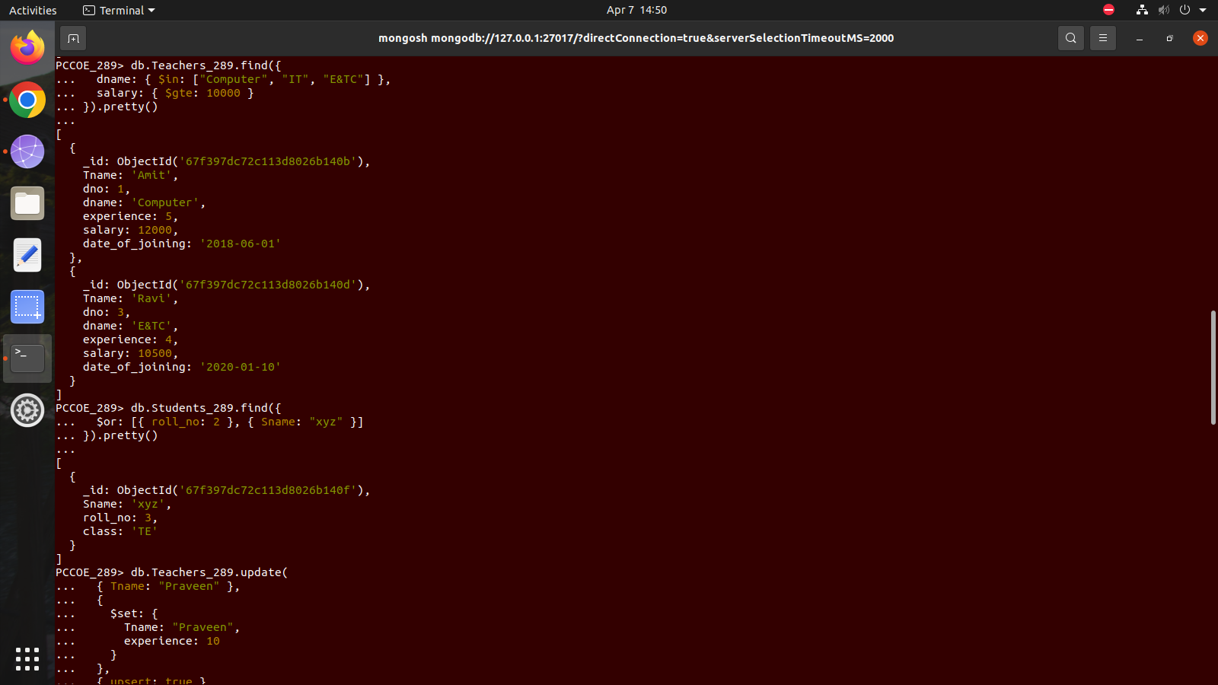

7. Find the student information having roll_no = 2 or Sname=xyz

db.Students_289.find({
$or: [{ roll_no: 2 }, { Sname: "xyz" }]
}).pretty()



8. Update the experience of teacher-praveen to 10years, if the entry is not available in database consider the entry as new entry.

db.Teachers_289.update(
{ Tname: "Praveen" },
{
$set: {
Tname: "Praveen",
experience: 10
}
},
{ upsert: true }
)

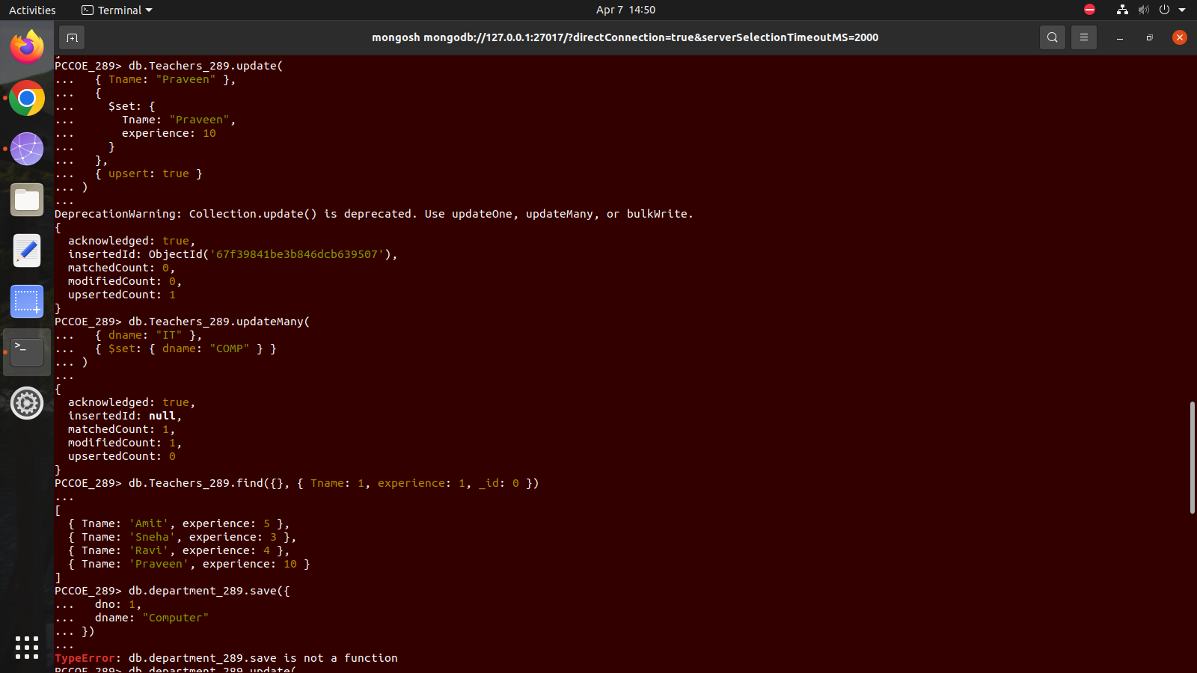
9. Update the deparment of all the teachers working in IT deprtment to COMP

db.Teachers_289.updateMany(
{ dname: "IT" },
{ $set: { dname: "COMP" } }
)


10. find the teachers name and their experience from teachers collection

db.Teachers_289.find({}, { Tname: 1, experience: 1, _id: 0 })


11. Using Save() method insert one entry in department collection

db.department_289.update(
{ dno: 1 },
{ $set: { dno: 1, dname: "Computer" } },
{ upsert: true }
)

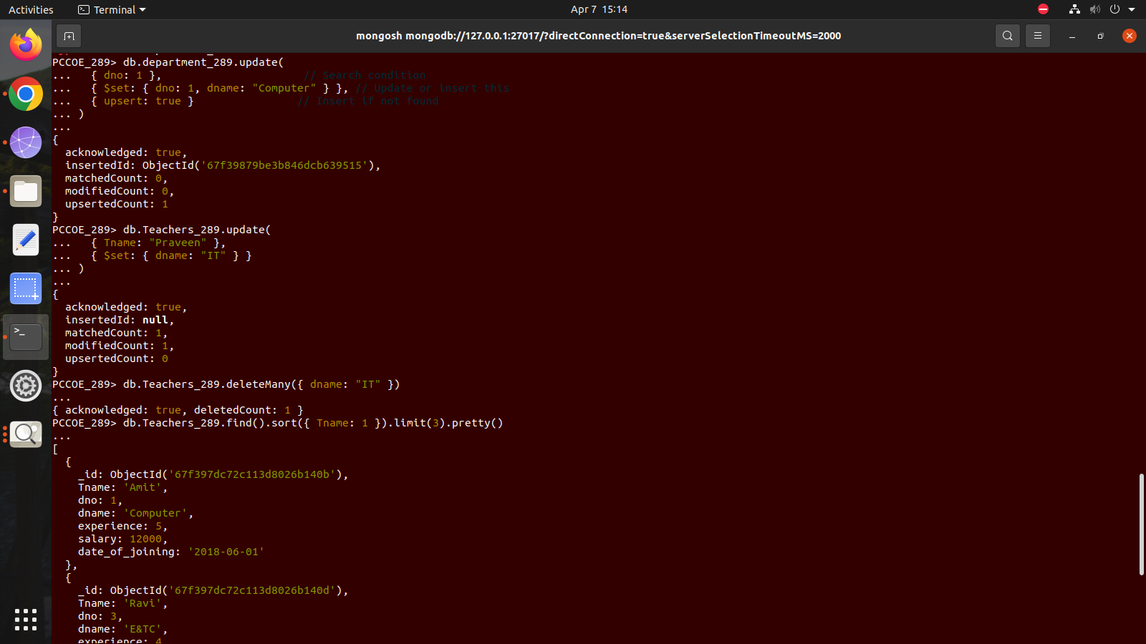

12. Using Save() method change the dept of teacher praveen to IT

db.Teachers_289.save({
Tname: "Praveen",
dname: "IT"
})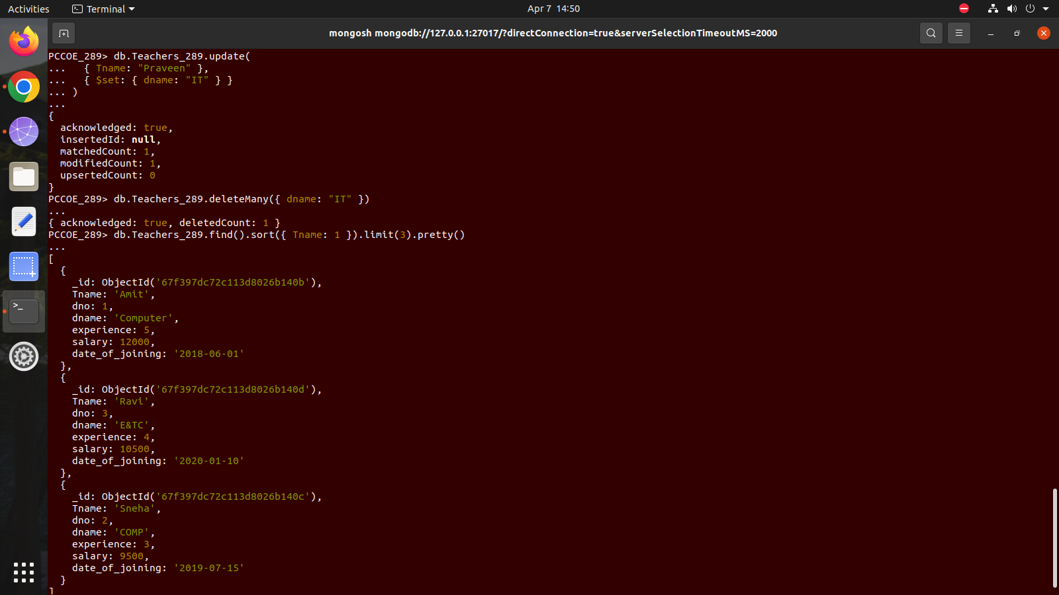

13. Delete all the doccuments from teachers collection having IT dept.

db.Teachers_289.deleteMany({ dname: "IT" })


14. display with pretty() method, the first 3 doccuments in teachers collection in ascending order

db.Teachers_289.find().sort({ Tname: 1 }).limit(3).pretty()



